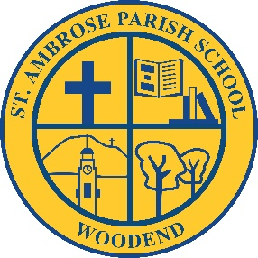

St Ambrose Parish School

Science Curriculum Policy

Rationale
Science provides an empirical way of answering interesting and important questions about the biological, physical and technological world. Science is a dynamic, collaborative and creative human endeavour arising from our desire to make sense of our world by exploring the unknown, investigating universal mysteries, making predictions and solving problems. Science knowledge is contestable and is revised, refined and extended as new evidence arises.

Aim
Through the Science curriculum we aim to provide opportunities for students to develop an understanding of:
- Important scientific concepts and processes
- The practices used to develop scientific knowledge,
- The contribution of science to our culture and society, and its applications in our lives.
The curriculum supports students to develop the scientific knowledge, understandings and skills to make informed decisions about local, national and global issues and to participate, if they so wish, in science-related careers.

Science teaching and learning at St Ambrose Primary School aims to foster and develop student interest in science, expand curiosities and encourage students to explore and question the world they live in. Students develop their science understandings through collaborative learning experiences, where they listen to different opinions, justify their ideas with evidence, and critically question the ideas of others.

The programme aims to provide a solid foundation of science understandings through four term units on Earth and Space, Biological, Chemical, and Physical Sciences. All units are based on the content descriptions as outlined in the Victorian Curriculum.
http://victoriancurriculum.vcaa.vic.edu.au/science/curriculum/f-10

Science literacy skills and scientific inquiry methods are integrated throughout all units of work, including questioning, planning and conducting experiments and investigations, collecting and analysing data, evaluating results, and drawing evidence-based conclusions.

Implementation

The Science program at St Ambrose Primary School is delivered through the Integrated Studies curriculum topics within the classroom program.
.
Evaluation:

- This policy will be reviewed as part of the school’s three year review cycle unless an issue arises which requires earlier review.

